Live Science Magazine By Tia Ghose July 26, 2017

**Stunning Dark Images Reveal Movement of Trillion-Ton Antarctic Iceberg**

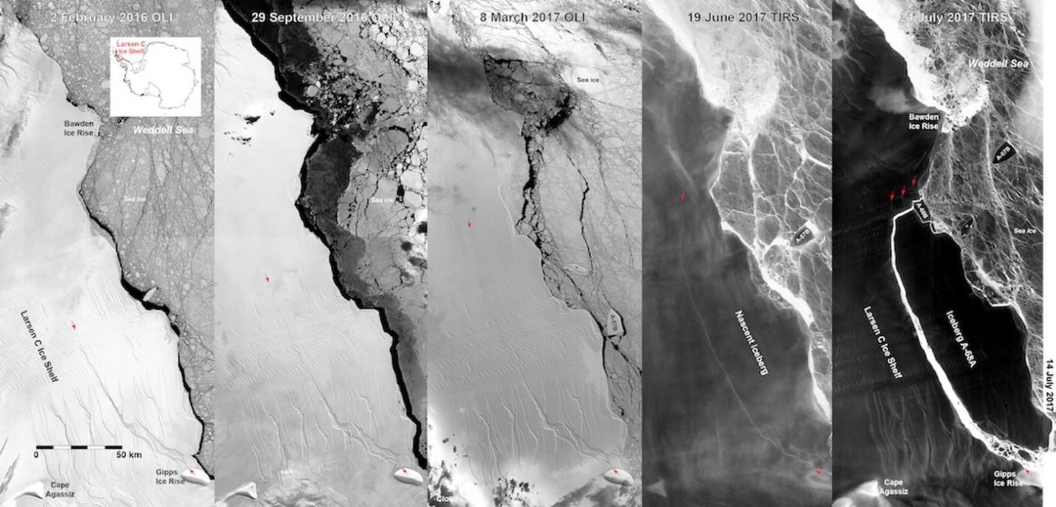

composite images from NASA's satellite imagery reveal the slow calving of a massive iceberg from Antarctica's Larsen C ice shelf over many months.

Gorgeous new images reveal the movement of an enormous, trillion-ton iceberg that recently broke off from the Larsen C ice shelf in Antarctica

Right now, it is winter in Antarctica and the coldest continent is shrouded in a long night. But the movement of the Delaware-size hunk of ice was captured thanks to infrared satellite imagery from NASA that can see in the dark. [[See Images of Larsen C Ice Shelf and Rift](https://www.livescience.com/59650-photos-antarctica-larsen-c-ice-shelf.html)]

The [massive iceberg's split](https://www.livescience.com/59797-antarctica-larsen-c-iceberg-space-image.html) from the continent had been predicted for years, due to the rapid movement of the ice shelf. Sometime between July 10 and July 12, the gargantuan hunk of ice, weighing in at a mind-boggling trillion tons, finally broke off, shaving off between 9 and 12 percent of the ice shelf's total mass, [Live Science previously reported](https://www.nasa.gov/feature/goddard/2017/landsat-sees-in-the-dark-the-evolution-of-antarctica-s-delaware-sized-iceberg).

The new images were snapped between July 14 and July 21 by the Thermal Infrared Sensor aboard NASA's Landsat 8 satellite. The eerie new images reveal that the 2,240-square-mile (5,800 square kilometers) iceberg has already begun its inevitable disintegration. The main iceberg, dubbed A-68, has already lost some pieces, according to NASA. Currents are carrying the big berg northward, away from its shelter in a bay near the main ice shelf.

The images also reveal three new baby icebergs that are also likely to make their way into the sea soon.

OVER

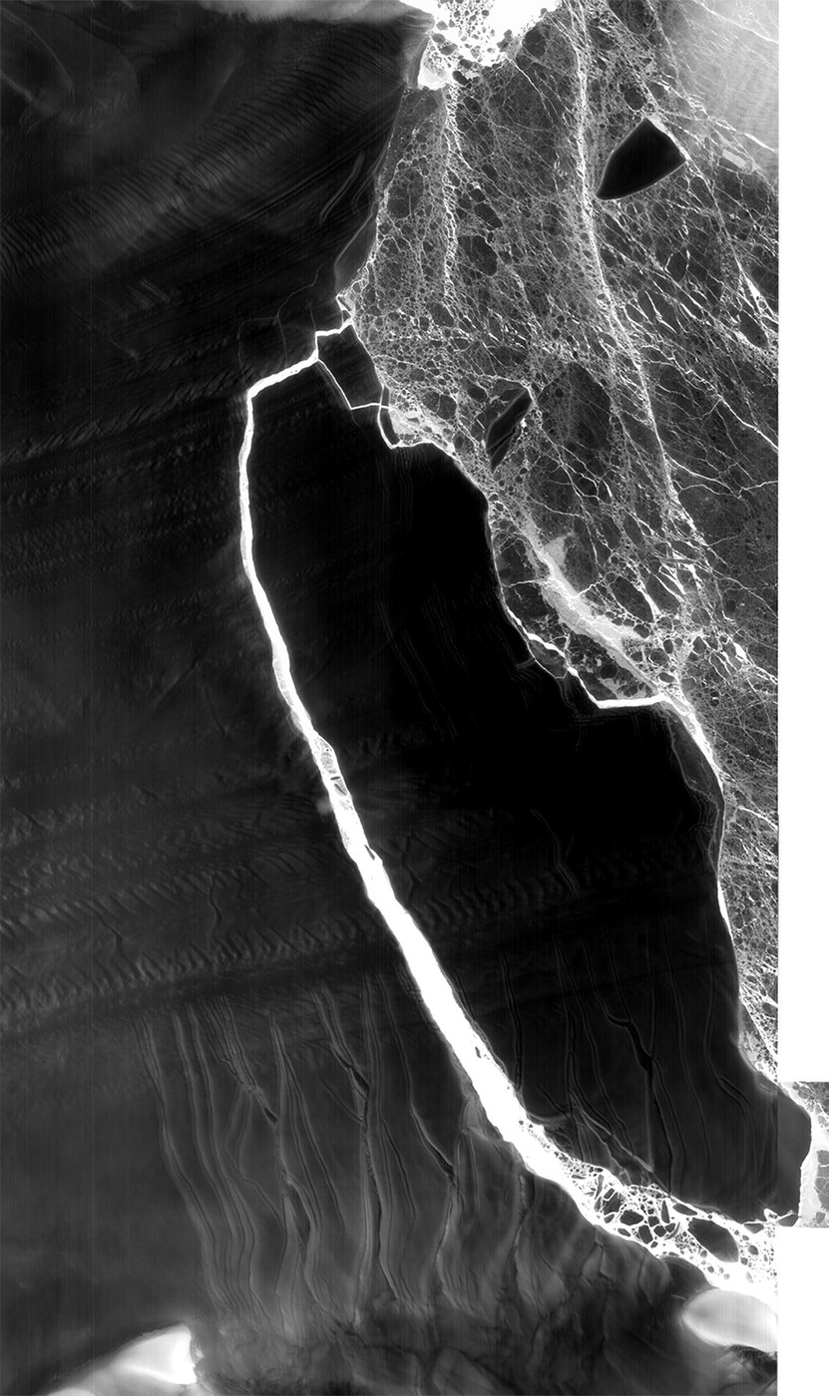

Gorgeous new "dark" images of a massive iceberg moving off from the Larsen C ice shelf in Antarctica were recently captured by a NASA infrared sensor aboard a satellite.